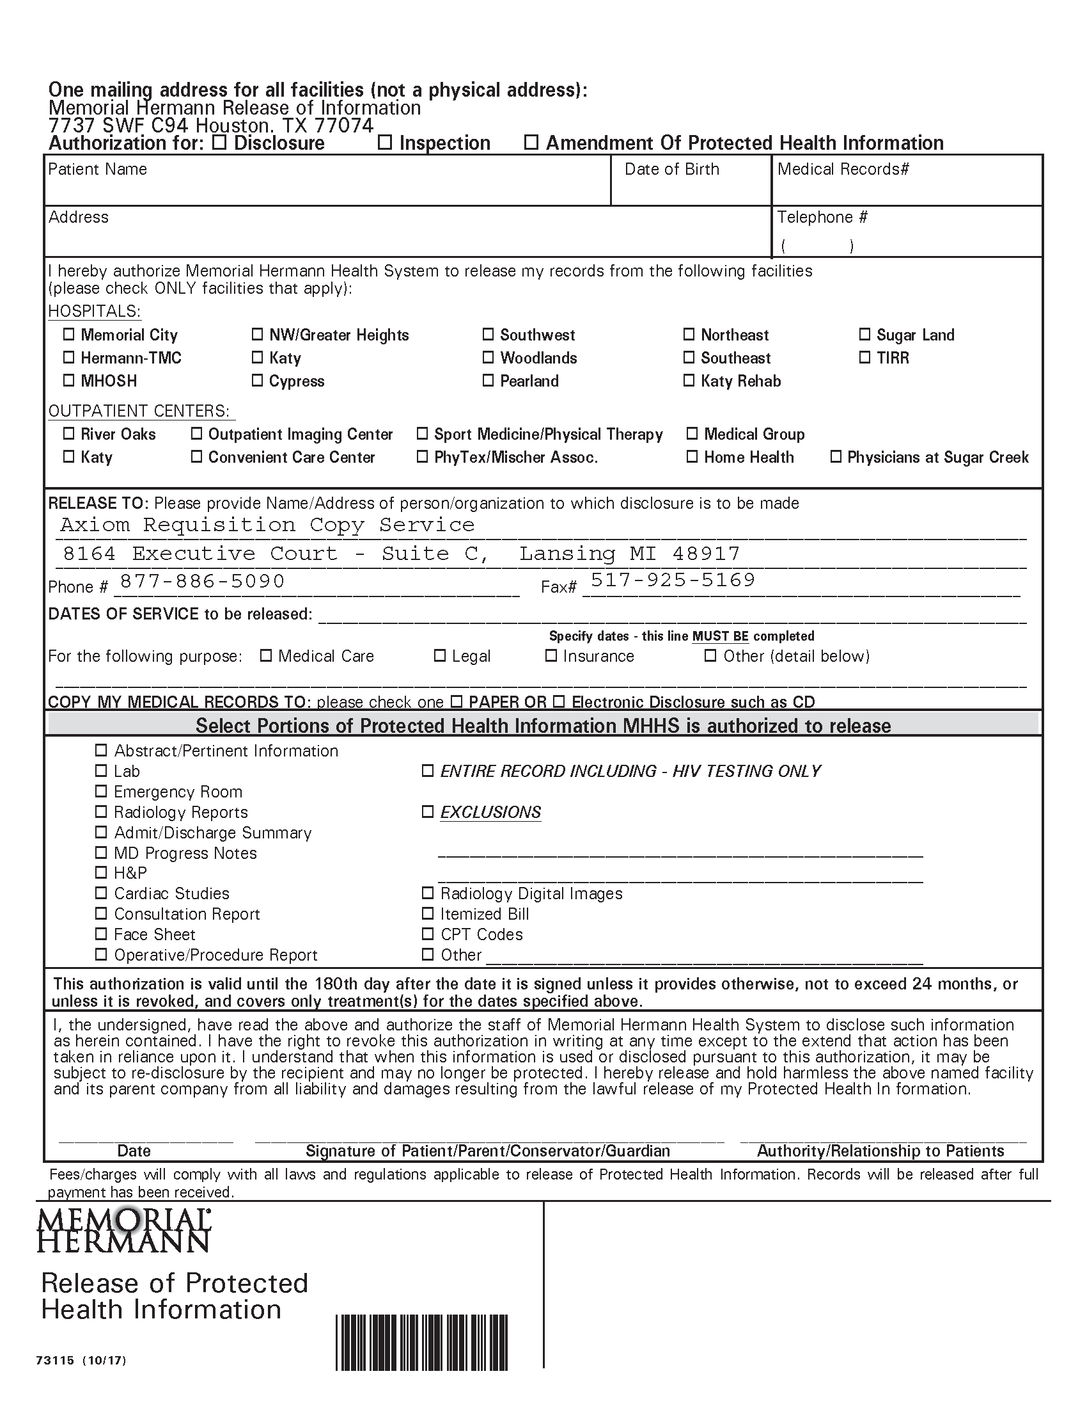
Batman
Secret Location Under Office Building Gotham, NJ
01/01/1979
FROM 01/01/1979 TO PRESENT: Any and all MEDICAL RECORDS, including but not limited to patient history form(s), reports, etc. pertaining to Batman SSN: xxx-xx-5555, DOB: 01/01/1979.
X
X
X

